ZIngo  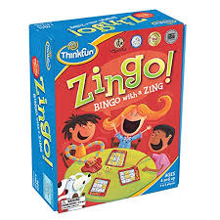  intermediate level  Ages: Upper elementary to high school | Pieces included in visuals  Rules for game  - Have students take turns pushing the lever the pieces  - Using the visuals, they can say “I got ____ and _____”  - Have the student match with their board first, then ask the group using the visuals “Do you need____?” or the peers can say “Can I have______?”  - Play the game until someone’s board is filled up  Additional Tips and Ideas  - Set a timer and keep playing until the timer goes off  - Have students talk about if they got a match or no match  - Have students answer yes or no when they asked “Do you need ____?”

